**9.EXCEPTION HANDLING**

**NAME:ENIYA .B.A**

**ROLL NO:230701085**

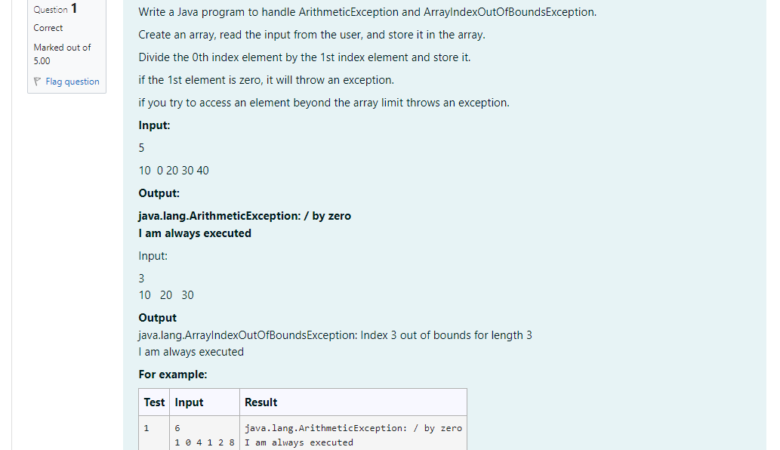

CODE:

import java.util.Scanner;

public class Exception{

public static void main(String[] args) {

Scanner scanner = new Scanner(System.in);

try {

int size = scanner.nextInt();

int[] arr = new int[size];

for (int i = 0; i < size; i++) {

arr[i] = scanner.nextInt();

}

int result = arr[0] / arr[1];

System.out.println("Accessing out-of-bounds element: " + arr[3]);

} catch (ArithmeticException e) {

System.out.println("java.lang.ArithmeticException: " + e.getMessage());

} catch (ArrayIndexOutOfBoundsException e) {

System.out.println("java.lang.ArrayIndexOutOfBoundsException: " + e.getMessage());

} finally {

System.out.println("I am always executed");

}

}

}

OUTPUT: 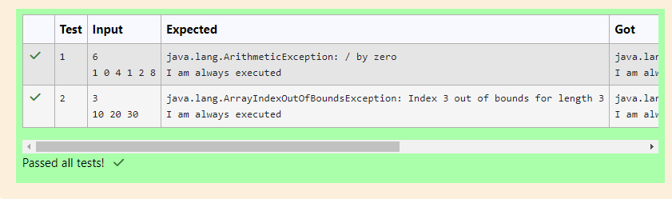

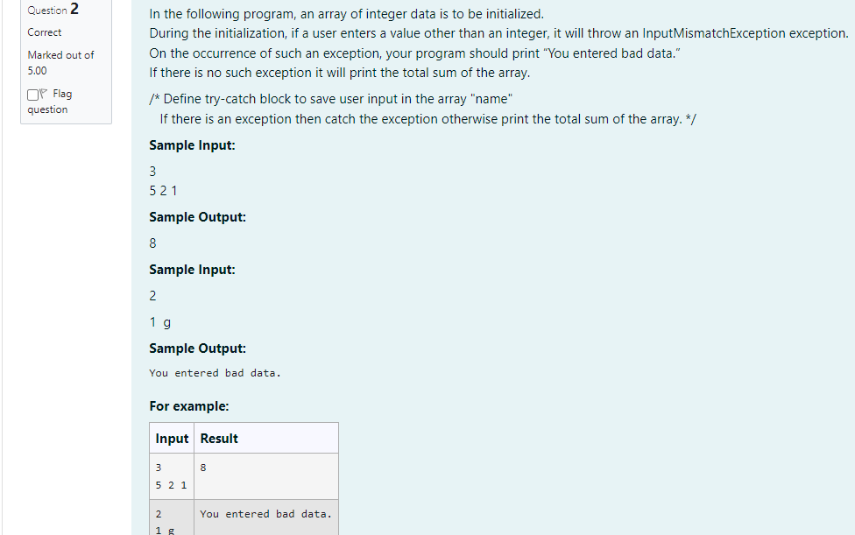

CODE:

import java.util.Scanner;

import java.util.InputMismatchException;

class prog {

public static void main(String[] args) {

Scanner sc = new Scanner(System.in);

int i;

int length = sc.nextInt();

// create an array to save user input

int[] name = new int[length];

int sum=0;//save the total sum of the array.

/* Define try-catch block to save user input in the array "name"

If there is an exception then catch the exception otherwise print

the total sum of the array. */

try

{

for(i=0;i<length;i++){

name[i]=sc.nextInt();

sum=sum+name[i];

}

System.out.println(sum);

}

catch(Exception e)

{

System.out.println("You entered bad data.");

}

}

}

OUTPUT:

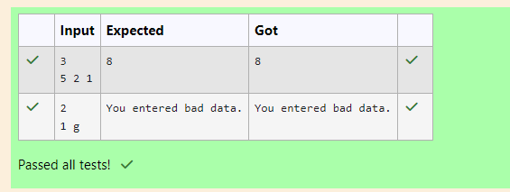

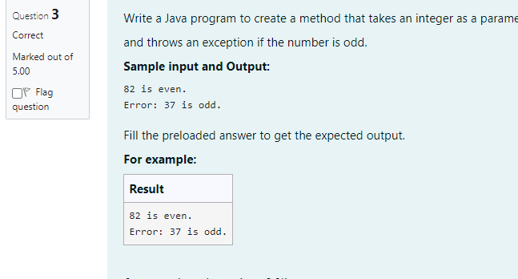

CODE:

class prog {

public static void main(String[] args) {

int n = 82;

trynumber(n);

n = 37;

trynumber(n);

}

public static void trynumber(int n) {

try {

checkEvenNumber(n);

System.out.println(n + " is even.");

} catch (IllegalArgumentException e) {

System.out.println("Error: " + e.getMessage());

}

}

public static void checkEvenNumber(int number) {

if (number % 2 != 0) {

throw new IllegalArgumentException(number + " is odd.");

}

}

}

OUTPUT:  
